Early Fault Detection in Solar PV Systems
Using Machine Learning

ELECTRICAL ENGINEERING PROJECT

EEM-705

Ansh Prasad-2104221
Dept. of Electrical Engineering
Dayalbagh Educational Institute Agra, India
anshprasad01@gmail.com
Tanvi Malik-2104268
Dept. of Electrical Engineering
Dayalbagh Educational Institute Agra, India
tmalikagr04@gmail.com

Under the guidance of Prof. G.S. Sailesh Babu


2023 – 2024
Department of Electrical Engineering
Faculty of Engineering
Dayalbagh Educational Institute (Deemed to be University)
Agra – 282005

Signature of Supervisor:

_____________________

Signature of External Examiner:

_________________________

ACKNOWLEDGEMENT
We would like to express our heartfelt gratitude to all those who have contributed to the development and realization of this project report of Ideation and the feasibility of the idea. We extend our deepest appreciation to our project advisor and mentor, Prof. G.S Sailesh Babu for their invaluable guidance, unwavering support, and expert insights throughout the research and writing process. Your mentorship has been instrumental in shaping this endeavor. Lastly, we express our appreciation to all those who share the commitment to sustainability and eco-friendliness, and who continue to inspire me to pursue this vision of a greener and brighter future.
Thank you for being part of this journey.

ABSTRACT
The rapid adoption of solar energy as a sustainable alternative to fossil fuels has necessitated advancements in system reliability and fault detection. The United Nations has set a goal to ensure global access to affordable, sustainable, and clean energy, underscoring the importance of optimizing renewable energy systems. This study presents a machine learning-based approach for early fault detection in solar photovoltaic (PV) systems, utilizing real-time data collected from an educational institute’s rooftop solar installation. The dataset comprises an average of 144 daily instances, captured at 10-minute intervals (or more frequently if warning logs occur), over the period from May 2022 to May 2023. A subset of parameters, selected from a broader dataset, was analyzed to explore seasonal and operational variations in the system’s performance.
The project focuses on evaluating the energy performance of the PV system and training machine learning models to detect anomalies indicative of potential faults at an early stage. This proactive approach aims to enhance the operational efficiency and reliability of solar PV systems, contributing to the global transition toward sustainable energy solutions.

TABLE OF CONTENT

1: INTRODUCTION 5
2: MOTIVATION TO SELECT THE PROBELM 7
3: LITRATURE REVIEW 8
4: OBJECTIVES 10
5: CONCLUSION 11
5.1: DATA 11
5.1.1: Data Collection 11
5.1.2: Data Analysis 12
5.2: FALUT DECTECTION AND CLASSIFICATION 13
5.2.1: Feature Selection 13
5.2.1: Classification 13
5.2.3: Machine Learning Integration 14
5.2.4: Model Training and Evaluation 14
6: RESULTS AND DISCUSSION 15
7: CONCLUSION 18
8: WORK REMAIN 19
9: TIMELINE 21
10: REFRENCE 22

INTRODUCTION
The increasing global demand for clean and sustainable energy has led to a significant rise in the adoption of Solar Photovoltaic (PV) systems. Effective monitoring and fault detection in these systems are critical to ensure their efficiency and reliability. This project discusses a comprehensive approach to studying and improving the performance of PV systems by leveraging advanced methodologies and technologies.
Typically the energy flow in solar (PV) system, during the day, solar panels capture sunlight and convert it into electricity, which flows directly to power appliances if they are running. Any excess energy, beyond what is immediately needed, is either stored in batteries for later use or exported to the grid if net metering is enabled. In cloudy or low-sunlight conditions, solar generation decreases; the system compensates by drawing energy from the batteries or, if needed, from the grid. At night, when solar panels are inactive, stored energy from the batteries is used to power appliances. If the batteries are depleted or not installed, the system seamlessly switches to the grid to ensure uninterrupted power. In hybrid setups, smart management systems prioritize battery use first, followed by the grid as a backup. Throughout the process, sensors monitor energy production, storage levels, and consumption, optimizing efficiency while sending alerts for maintenance or faults. This ensures reliable, sustainable energy flow under all conditions.
Solar Photovoltaic (PV) system from which we received data, as described in [1], comprises a 40 kWp PV array, a 96 kWh battery storage unit, a 40 kVA grid-support conditioner (GSC), and a data acquisition system. The PV array, tilted at 27° and facing south, consists of 170 Wp monocrystalline silicon modules grouped into 24 strings, each with 10 modules, achieving a system voltage of 240 VDC. Connected to the same DC bus is a string of 120 low-maintenance lead-acid batteries rated at 2V, 400Ah each. An integrated inverter with a Maximum Power Point Tracking (MPPT) charge controller enables continuous data logging with a 10-minute resolution, facilitating detailed energy flow analysis. Over a one-year study, the system generated an annual energy output of 31.35 MWh, with peak generation occurring in April and May due to favorable environmental conditions such as higher solar insolation and cleaner modules.
Fault detection in PV systems is a crucial component of their operation. As highlighted in, an effective fault detection methodology involves comparing measured AC power production with predictions from a simple yet accurate model. Significant deviations between these values are used to identify faults. Unlike complex simulation-based or artificial intelligence-dependent processes of models, this approach is low in complexity and requires minimal prior knowledge, making it adaptable to various PV installations. This model can also be automated to calculate normal operational limits and detect abnormal behavior, ensuring the system remains reliable and efficient.
For utility-scale solar installations, which can produce over 50 MW of electricity, maintaining efficiency and minimizing maintenance costs is a challenge. Conventional monitoring systems rely on detailed analytics of parameters such as voltage, current, temperature, and irradiance. Machine learning-based techniques, as discussed in [3], are now widely used to automate performance monitoring, detect faults, and optimize the operation of large-scale PV arrays. These algorithms reduce the burden on human operators while enhancing the overall performance of photovoltaic systems under varying conditions [3].
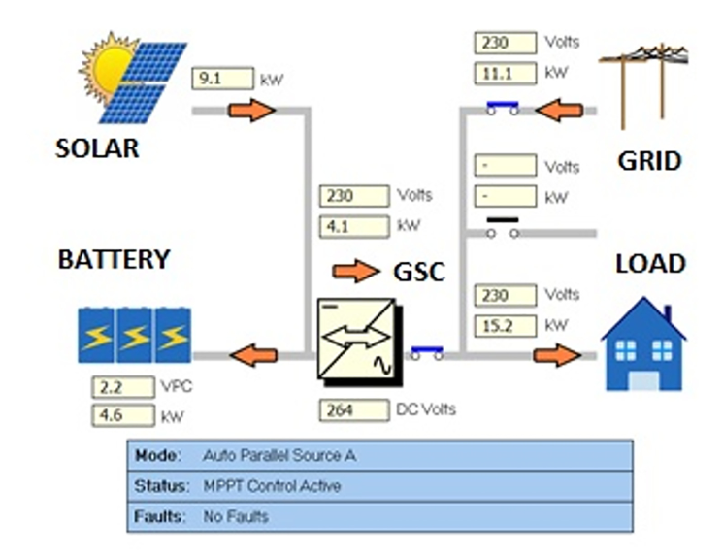
Fig.1 Structure of PV System (real-time interface)

MOTIVATION TO SELECT THE PROBLEM
The increasing reliance on solar photovoltaic (PV) systems for sustainable energy production has emphasized the need for reliable fault detection and system optimization. Faults in solar PV systems—caused by issues such as shading, soiling, inverter failures, and wiring defects—can lead to significant energy losses, increased downtime, and higher maintenance costs.
Traditional fault detection methods, including manual inspections and basic monitoring systems, are inadequate for addressing the dynamic and complex nature of solar PV operations. These methods often fail to detect faults promptly, leading to prolonged inefficiencies. With advancements in data analytics and machine learning, it has become possible to leverage high-frequency operational data to build predictive models for early fault detection. This study aims to utilize real-time data to identify fault patterns and classify system states, thereby improving system reliability and reducing operational disruptions

LITRATURE REVIEW
- Performance of Machine Learning Algorithms
Eshrag A. Refaee et.al. Presented the evaluation of different machine learning algorithms that shows that the J48 decision tree outperforms other methods, achieving an accuracy of 98.85% with high precision (0.989) and recall (0.989). Random Forest and Linear Regression also delivered competitive results, with accuracies of 98.28% and 97.25%, respectively. In contrast, traditional methods, such as ZeroR, perform poorly, achieving only 45.65% accuracy, underscoring the necessity of advanced ML techniques for fault detection. [1]

- Role of Deep Learning Models
Veerapandiyan Veerasamy et.al. Presented Deep learning methods such as CNN and LSTM also exhibit strong performance. The proposed LSTM classifier achieved an overall classification accuracy of 91.21% with a success rate of 92.42% in identifying high-impedance faults (HIF). The robustness of the LSTM model is validated through high kappa statistics, precision, recall, and F-measure scores, making it a reliable choice for dynamic fault detection. [2]

- Impact of Data Granularity
Radu Platon et.al. highlights the significance of temporal granularity in achieving a high fault-detection accuracy. Models trained on hourly average data outperform those using 10-minute intervals, indicating that reducing noise in the data improves detection rates. Additionally, segmenting the data based on irradiance intervals led to detection rates exceeding 90%, further validating this approach.[3]

- Battery Storage and Self-Consumption
K. Pritam Satsangi et.al. shows that integrating battery storage significantly improves the system's self-consumption rate, achieving 89%, which is the highest among reported systems globally. This finding highlights the potential of such grid systems to contribute to renewable energy targets and provide appropriate incentives to offset storage costs. [4]

- Comparison with Existing Literature
The findings of this study align with existing research, where ML models demonstrate superior fault-detection capabilities compared to traditional methods. However, this study advances the state-of-the-art by combining performance metrics, temporal data granularity, and environmental robustness to create a holistic solution.

OBJECTIVES
- To investigate the limitations of current fault detection methods
This includes identifying the challenges in existing methods, such as scalability, real-time detection capabilities, and accuracy, which hinder their deployment in diverse PV setups.

- To develop and implement a machine learning model
The model aims to detect faults like High Impedance Faults (HIF) and other performance anomalies early, thereby reducing system downtime and increasing energy output.

- To benchmark the performance of diverse ML algorithms
By comparing algorithms like J48 decision trees, Random Forest, CNN, and LSTM, the project will determine the most effective model based on precision, recall, and overall accuracy.

- To examine the effect of temporal granularity
Evaluating hourly data versus minute-level data will help optimize the model for higher detection rates and better system performance tracking.

- To validate the proposed ML model
This includes testing the model in various environmental conditions to ensure its robustness, adaptability, and reliability across different PV systems.

- To propose a practical framework
The framework will focus on making fault detection systems scalable and cost-effective for widespread use in real-world rooftop solar installations.

- To contribute to global renewable energy goals
The project will provide recommendations to help achieve higher adoption of rooftop solar systems, bridging the gap toward renewable energy targets

METHODOLOGY
This study proposes a data-driven approach to enhance the reliability and operational efficiency of solar PV systems by leveraging real-time data and machine learning for early fault detection. The steps draw inspiration from established methods, leveraging real-time data, advanced statistical techniques, and machine learning for robust fault detection and analysis.

Data

    - Data collection
Data was collected from a rooftop PV system installed at an educational institute, with a 40 kWp PV array integrated with battery storage and grid support. The dataset spans May 2022 to May 2023 and includes measurements taken at 10-minute intervals, such as:

 | Parameter | Description
1 | Date | Date of log data
2 | Time | Time of log data
3 | Description | Status or description of the data log
4 | Trigger | Changes that occurred triggering the log
5 | Inv kW Sum (kW) | Inverter power sum
6 | Load kW Sum (kW) | Load power sum
7 | Solar kW (kW) | Solar power generated
8 | Ambient Temp (°C) | Ambient temperature
9 | Solar Radiation (W/m²) | Solar radiation (DNI)
10 | Inv Exp kWh | Inverter export energy
11 | Inv Imp kWh | Inverter import energy
12 | Src A Exp kWh | Source A exported energy
13 | Src A Imp kWh | Source A imported energy
14 | Src B Exp kWh | Source B exported energy
15 | Src B Imp kWh | Source B imported energy
16 | Site kWh (calc) | Energy expended on site
17 | Batt Exp kWh | Battery exported energy
18 | Batt Imp kWh | Battery imported energy
19 | Solar kWh | Solar energy generated
    - Data Analysis
In our data analysis, we aim to comprehensively evaluate the performance and behavior of the solar energy system over the course of a year, focusing on the following key aspects:
- Energy Generation Analysis:
Assess the system's annual energy output of 31.35 MWh, with emphasis on identifying the months contributing the highest energy yields (May and June) and understanding variations during other months, influenced by factors such as insolation levels and module conditions.
- Solar Irradiation Trends:
Examine the monthly average solar radiation (in Wh/m²) to establish its relationship with energy generation patterns. This will help in understanding how seasonal changes and environmental conditions affect system performance.
- Battery Import/Export Dynamics:
Analyse the behaviour of battery energy import and export throughout the year. Specifically, focus on:
- The reliance on solar energy as the primary power source, followed by grid energy, and lastly, battery energy in rare cases.
- The disparity between battery input (higher due to trickle charge and full charge requirements) and output.
- The role of the battery in maintaining a reliable power supply to the load.
- Load vs. Solar Generation Performance:
Investigate the monthly variations in site load (in kWh) compared to solar generation. Highlight periods of load exceeding generation (e.g., winter months) and improved conditions during January and other favorable periods.

Fault Detection and Classification Methodology Using DNI

    - Feature Selection and Justification
- Direct Normal Irradiance (DNI): Used as the primary feature for analysis, as it is directly proportional to GHI and more relevant for solar panel performance.
- Supplementary Attributes: Include panel temperature, inverter efficiency, and derived parameters like the rate of change of DNI to enhance fault detection accuracy.
- Exclusion of GHI: GHI is omitted since its computation relies on DNI, and using DNI directly simplifies the process without compromising accuracy.
    - Classification Framework
Define operational classes based on normalized DNI values:
- Class 1 - Running (Green Zone): Normalized DNI (Norm DNI) > 0.7, indicating optimal solar system performance.
- Class 2 - Monitoring (Orange Zone): 0.3 ≤ Norm DNI ≤ 0.7, suggesting potential issues requiring closer observation.
- Class 3 - Inspecting (Red Zone): 0 ≤ Norm DNI < 0.3, signalling a need for immediate inspection due to underperformance.
Classifying input instances collected form solar systems

Class 1: running
1 < Norm DNI > 0.7

Class 2: monitoring
0.7 < Norm DNI > 0.3

Class 3: inspecting
0.3 < Norm DNI > 0

    - Machine Learning Integration
- Train a supervised learning mod using historical data with operational states.
- Use input features such as DNI, panel temperature, and DNI rate of change to enhance prediction accuracy.
    - Model Training and Evaluation
- Training Process:
  - Use pre-processed historical data to train the classification model.
  - Incorporate a balanced dataset to ensure adequate representation of all operational classes.
- Evaluation Metrics:
  - Assess model performance using accuracy, precision, recall, F1-score, and R² (coefficient of determination).
  - Conduct cross-validation to ensure reliability and robustness across unseen data.

RESULTS AND DISCUSSION
  - Data Analysis
Figure 2.The system was operational for 345 days, with the remaining days allocated to scheduled and unscheduled maintenance. Over the course of the year, the system generated a total of 31.35 MWh of energy. Higher energy yields were observed in June and May, while February, March, July, and August also saw a larger share of energy production. This was primarily due to higher insolation values during these months, combined with favorable conditions such as moderate cell temperatures (ranging from 27°C to 37°C) and cleaner modules in the later months compared to the earlier part of the year.
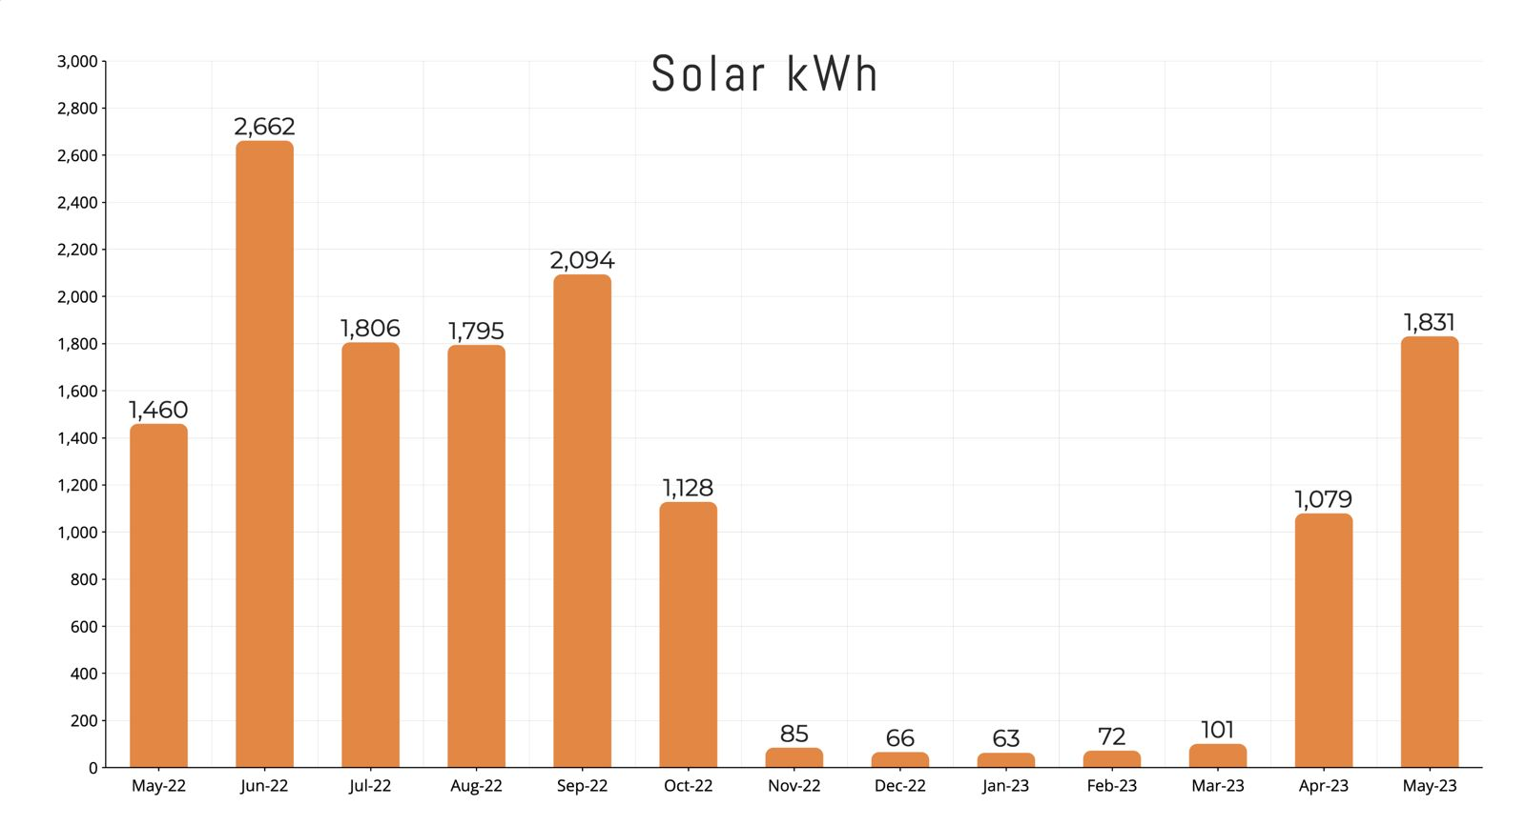
Fig.2 Monthly energy yield (Y_{E}).

Figure 3 illustrates the average monthly radiation input in W/m²,
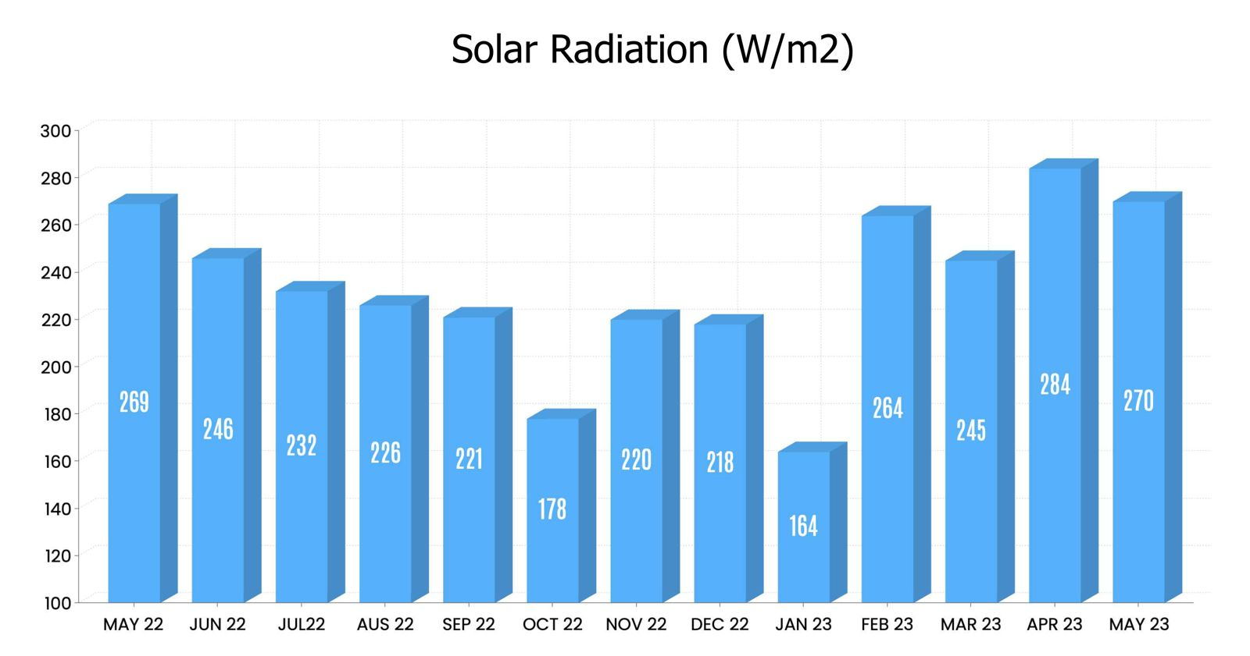
Fig.3 Monthly average solar irradiation (W/m²)
while Figure 4 shows the import and export of battery energy. Battery export refers to the energy transferred from the battery to the local load, while battery import indicates the energy drawn from the grid and solar to charge the batteries. The main objective of battery storage in the grid is to ensure a reliable supply to the load. The priority for supplying power is as follows: solar energy is the first source, followed by grid energy if solar output is insufficient, and lastly, battery energy is used in rare cases. As a result, battery export is typically much lower than battery import. Even when the battery is fully charged, it continues to receive a constant trickle charge from both solar and grid energy during the day, with only the grid providing power at night. This trickle charge is in addition to the energy needed to fully charge the battery, which explains the higher energy input compared to output.

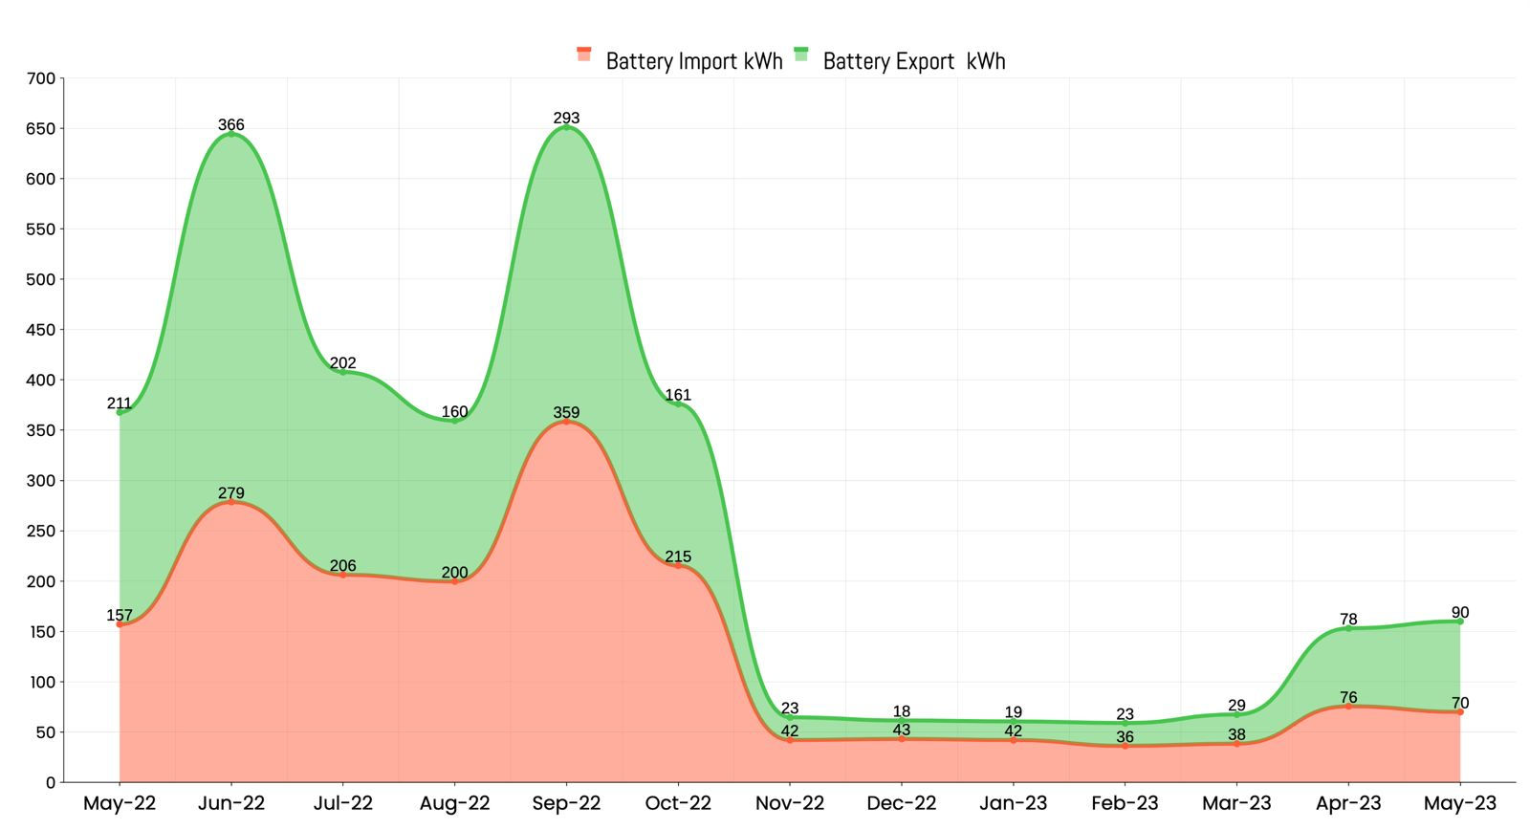
Fig.4 Monthly behavior of battery import/export.

Figure 5 depicts the behavior of site load (in kWh) and corresponding solar generation (in kWh) over the study period. During the winter months, when load slightly exceeds generation, the situation improves in January, February, and March, with load consistently outpacing generation. Finally,
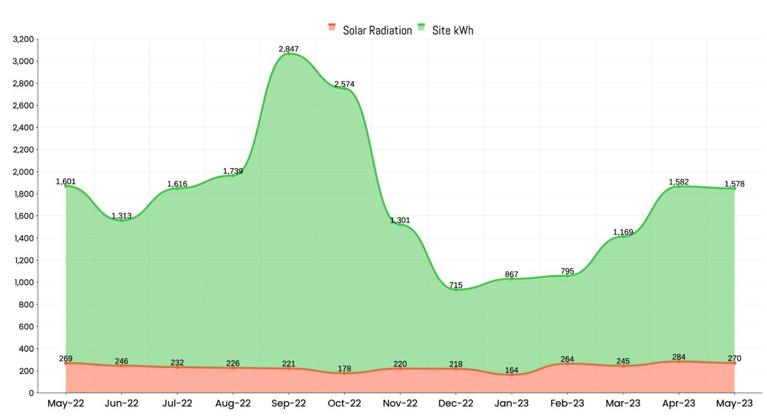
Fig.5 Monthly behavior of Solar radiation and Site KWh

CONCLUSION
In conclusion, this study highlights the critical role of continuous monitoring and data-driven analysis in maintaining the efficiency and reliability of solar photovoltaic (PV) systems. By analyzing operational data, the research identified key performance parameters and fault patterns, showcasing how real-time insights can improve early fault detection and optimize system performance. Seasonal variations, battery dynamics, and load-generation behavior were explored, providing a comprehensive understanding of system operations. The research also emphasized the importance of accurately identifying periods of low or excess generation, which is crucial for balancing energy supply and demand.
The findings underscore the importance of leveraging real-time data to detect potential issues, enhance decision-making processes, and improve overall energy management strategies. By understanding these patterns, operators can take proactive measures to prevent downtime and optimize energy output. While the study primarily focused on analyzing existing data and identifying fault trends, it establishes a solid foundation for future research. Advanced models incorporating machine learning algorithms and automated diagnostic systems can be developed to enhance fault detection capabilities, reduce maintenance costs, and further optimize the performance of solar PV systems. These advancements will contribute to improving system reliability, increasing energy yield, and supporting the long-term sustainability and efficiency of solar energy generation.

WORK REMAINS
Building upon the successful completion of the data analysis and classification framework, the following steps are planned to bring this project to completion:
- Machine Learning Model Training and Integration
  - Data Preparation: Pre-process the dataset further to ensure it is fully optimized for training, including feature scaling, handling any remaining missing values, and creating a balanced dataset for all operational classes.
  - Model Training: Train a supervised learning model, incorporating historical data with operational states. Utilize features such as Direct Normal Irradiance (DNI), panel temperature, and the rate of change of DNI to achieve high prediction accuracy.
- Model Evaluation and Validation
  - Evaluate the model using metrics such as accuracy, precision, recall, F1-score, and R² (coefficient of determination).
  - Perform cross-validation to ensure the model’s robustness and reliability across unseen data.
  - Fine-tune the model parameters to improve performance further, if necessary.
- Fault Detection and Automation
  - Integrate the trained model into a real-time fault detection system.
  - Implement a mechanism to classify faults based on normalized DNI values
and trigger appropriate alerts or actions for each operational class.
- Visualization and Reporting
  - Develop intuitive dashboards or visualizations to showcase system performance trends, classification results, and fault detection insights.
  - Compile a comprehensive report summarizing the system's performance, analysis results, and recommendations for future improvements.

- System Testing and Deployment
  - Test the fault detection system under various scenarios to validate its accuracy and responsiveness.
  - Deploy the system in a live environment to ensure smooth integration and operation.
- Documentation and Final Presentation
  - Prepare detailed documentation covering all aspects of the project, from data collection to system deployment.
  - Present the project outcomes, highlighting the impact and potential applications of the proposed methodology.
By completing these steps, the project will achieve its objectives of enhancing solar PV system reliability and operational efficiency through early fault detection powered by machine learning.

TIMELINE
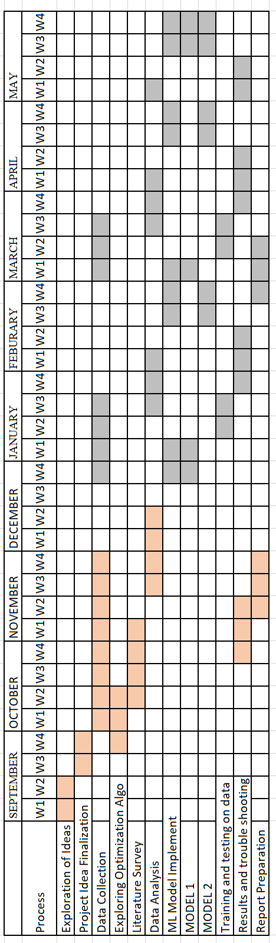

REFERENCE
[1] E. A. Refaee, "Using machine learning for performance classification and early fault detection in solar systems," *Mathematical Problems in Engineering*, vol. 2022, Art. no. 6447434, 9 pages, Apr. 2022. [Online]. Available: https://doi.org/10.1155/2022/6447434

[2] V. Veerasamy, N. I. A. Wahab, M. Othman, S. Padmanaban, K. Sekar, R. Ramachandran, A. Vinayagam, M. Z. Islam, and H. Hizam, "LSTM recurrent neural network classifier for high impedance fault detection in solar PV integrated power system," *IEEE Access*, vol. 9, pp. 31132–31143, Mar. 2021. [Online]. Available: https://doi.org/10.1109/ACCESS.2021.3060800

[3] R. Platon, J. Martel, N. Woodruff, and T. Y. Chau, "Online fault detection in PV systems," *IEEE Trans. Sustainable Energy*,2024,

[4] K. P. Satsangi, D. B. Das, G. S. S. Babu, and A. K. Saxena, "Real-time performance of solar photovoltaic microgrid in India focusing on self-consumption in institutional buildings," *Journal Name*, vol. XX, no. XX, pp. XX-XX, Jul. 2019. [Online].Available:https://www.sciencedirect.com/science/article/pii/S0973082618315837

[5] K. P. Satsangi, D. B. Das, G. S. S. Babu, and A. K. Saxena, "Real-time performance of solar photovoltaic microgrid in India focusing on self-consumption in institutional buildings," *Journal Name*, vol. XX, no. XX, pp. XX-XX, Jul. 2019. [Online].Available:https://www.sciencedirect.com/science/article/pii/S097308261831038X

[6] F. T. Liu, K. M. Ting, and Z.-H. Zhou, "Isolation forest," in *Proc. 2008 IEEE International Conference on Data Mining (ICDM)*, Pisa, Italy, 2008, pp. 413–422. doi: 10.1109/ICDM.2008.17.

